Technical Competency

Deepak

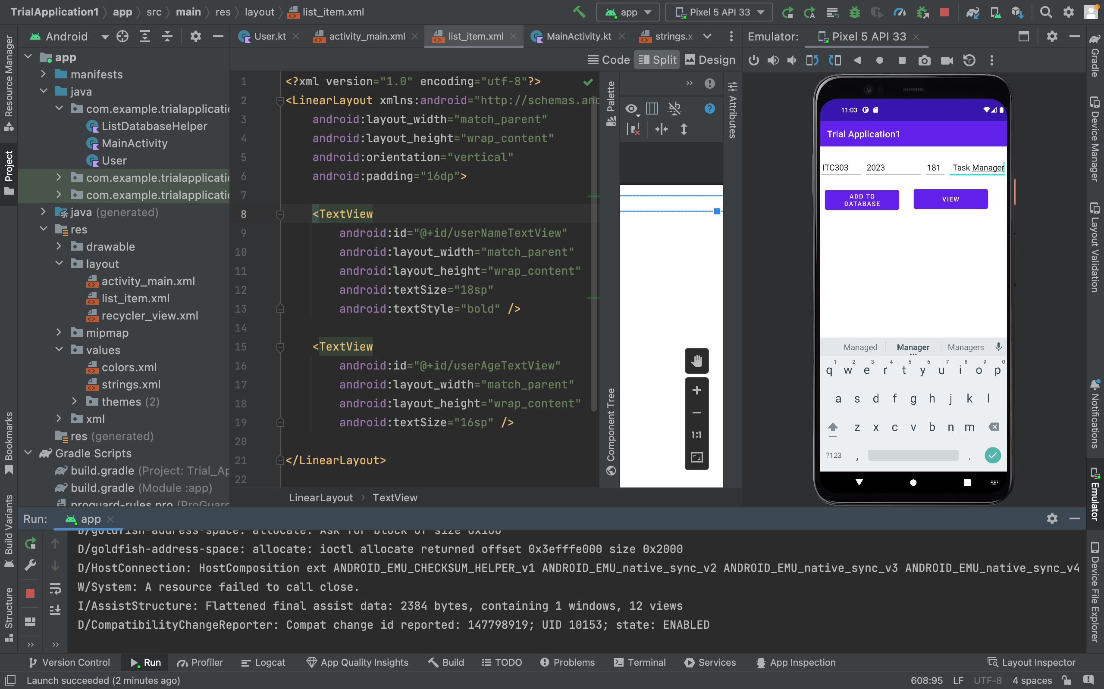

Entering data to be stored in the Sqlite database

4 fields to be stored

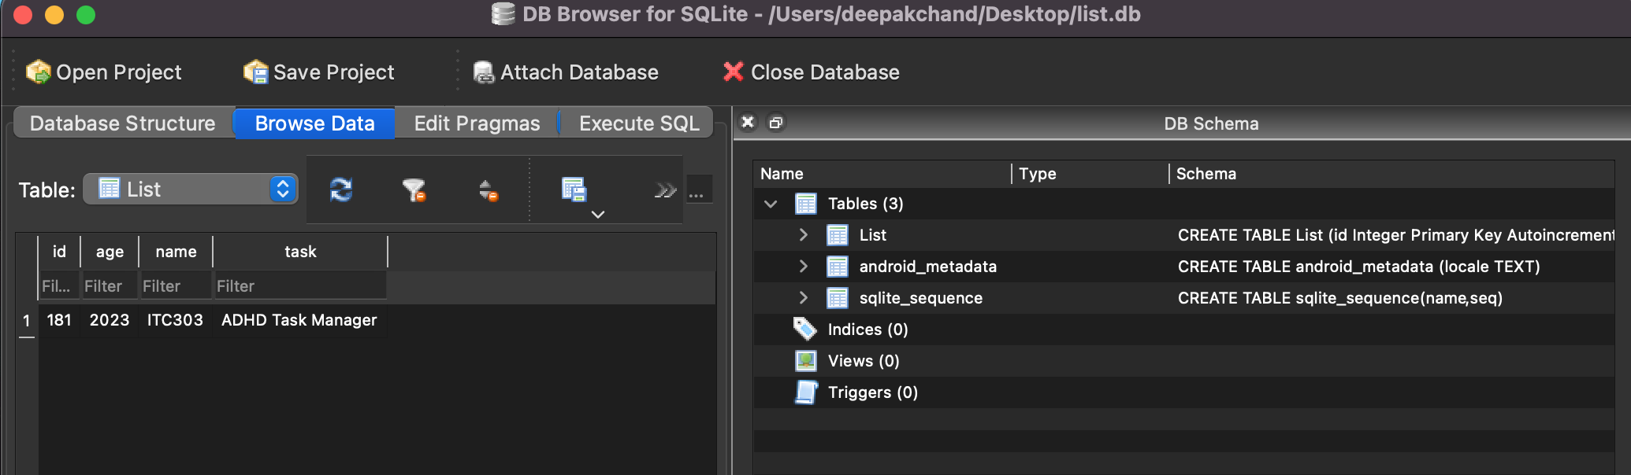

Data gets stored in the database.

Corie:

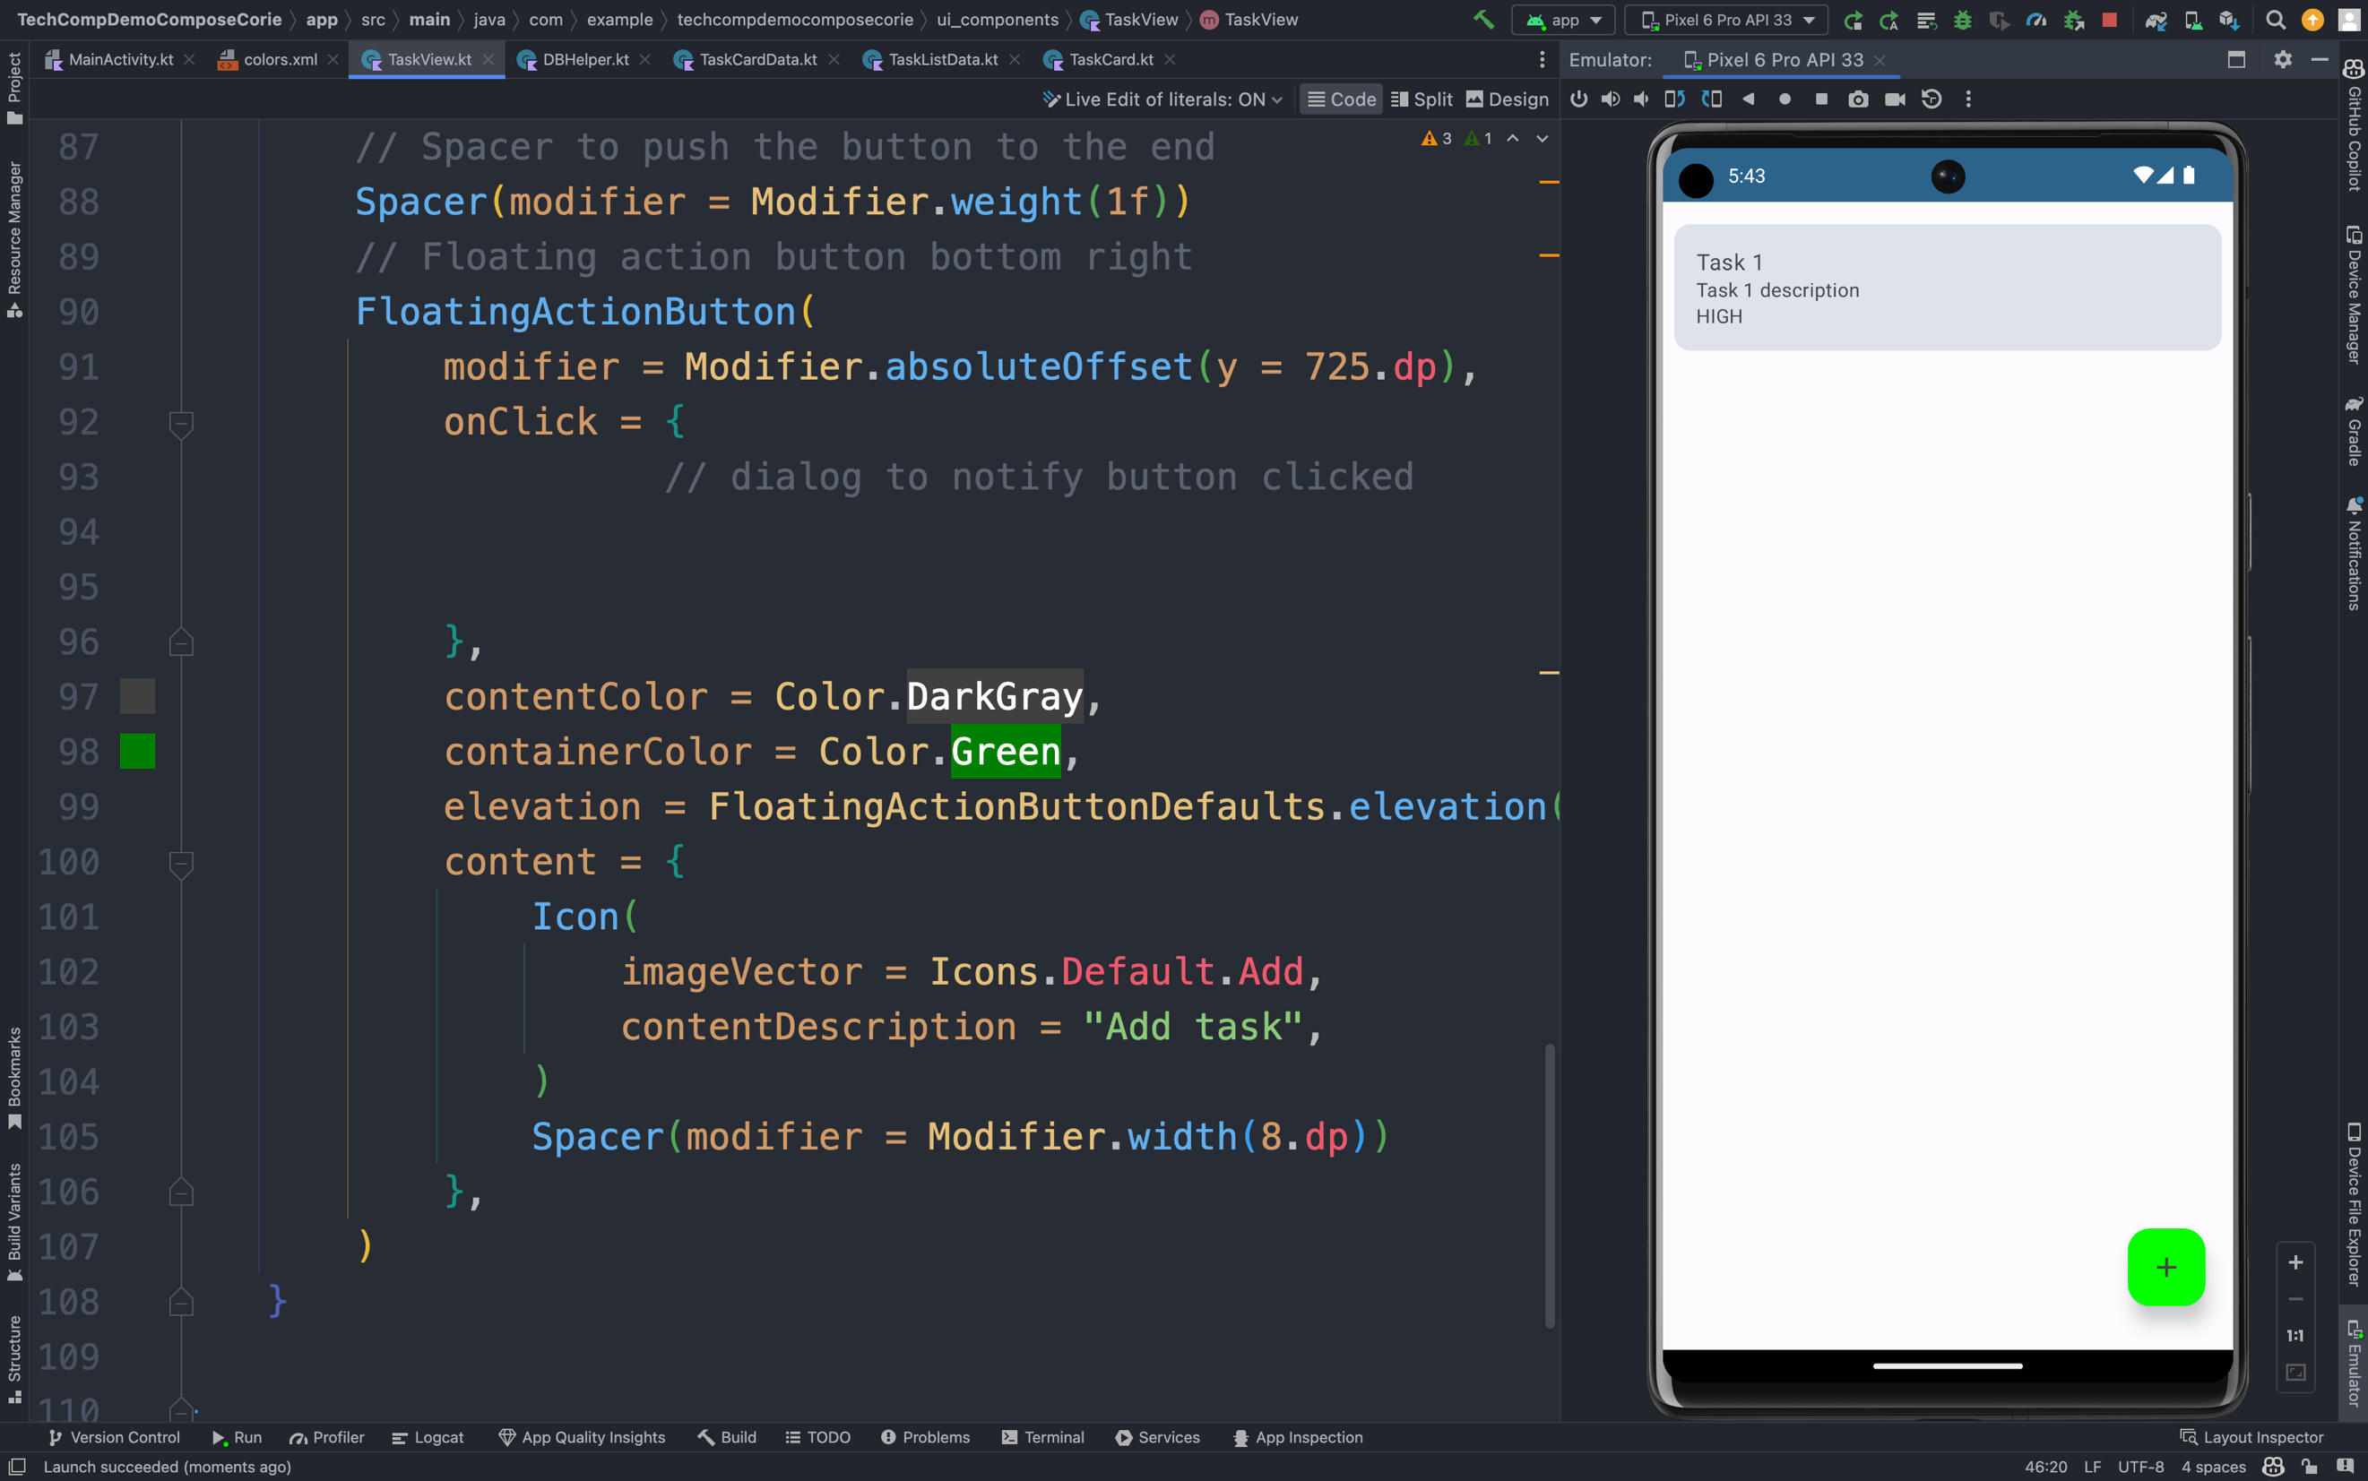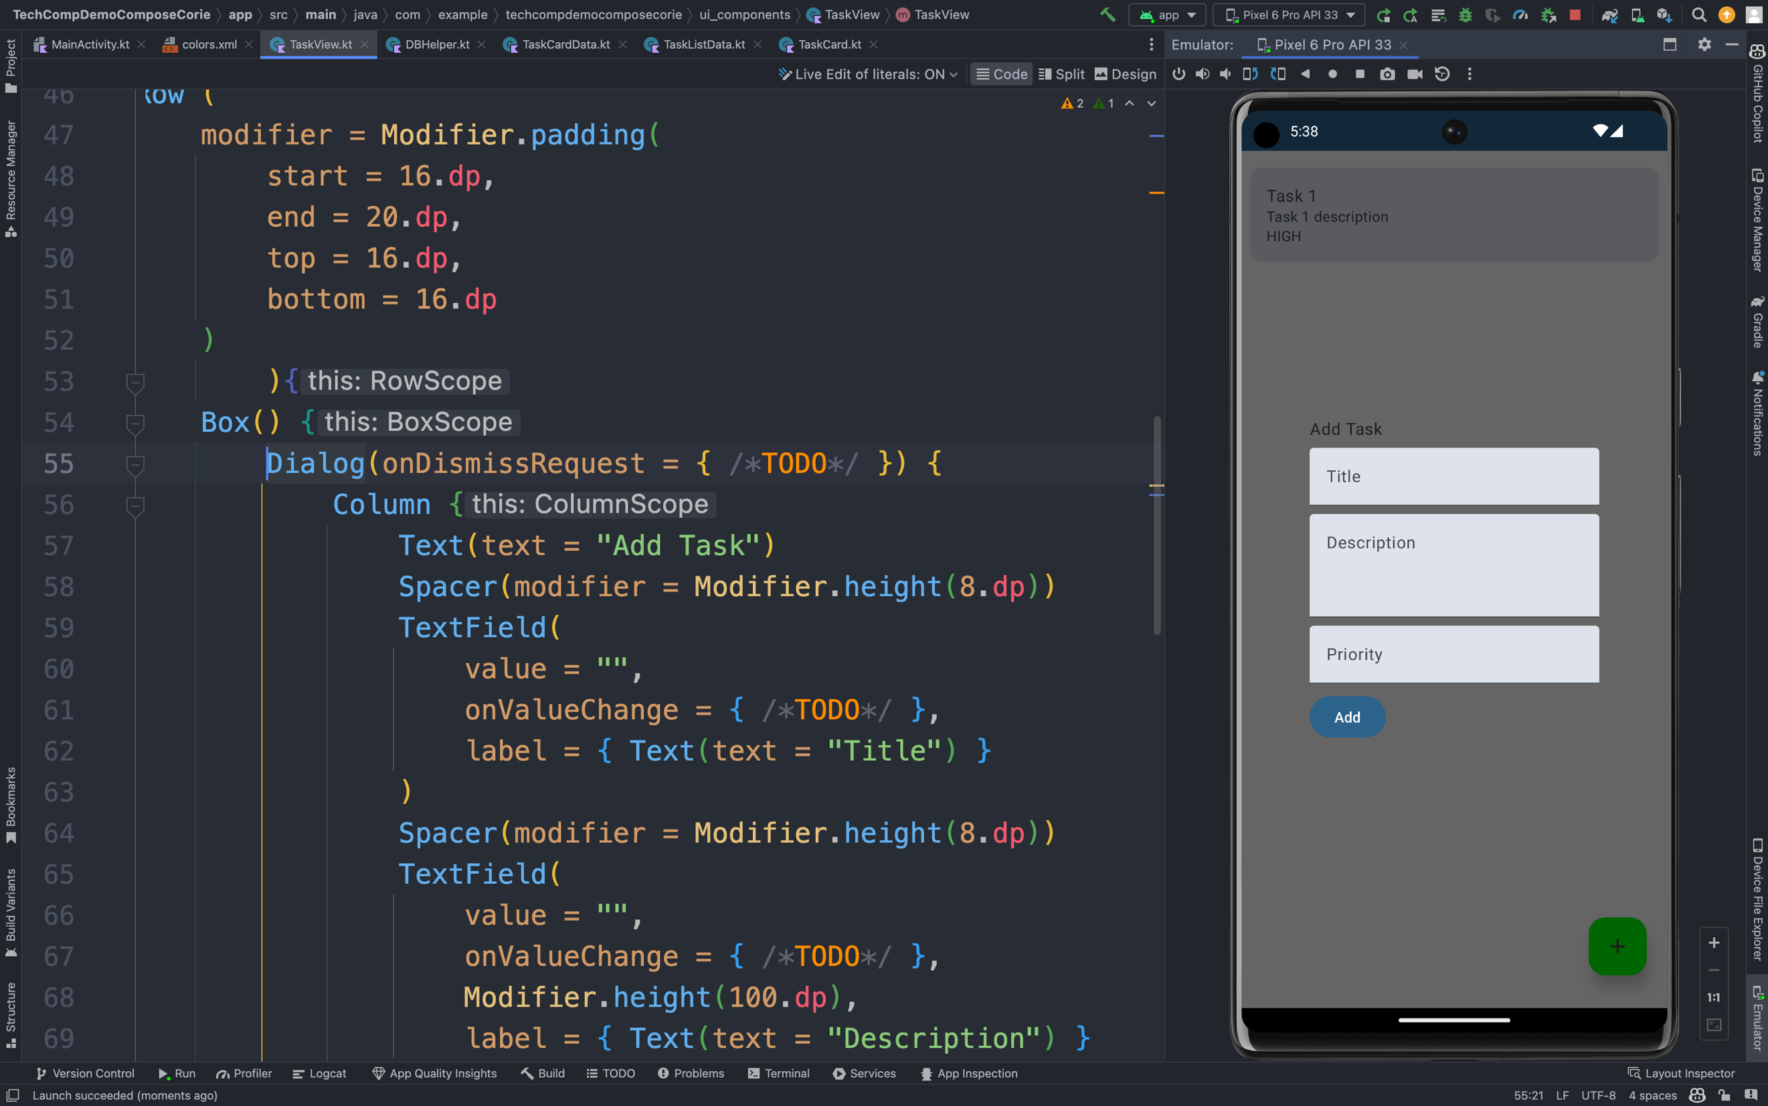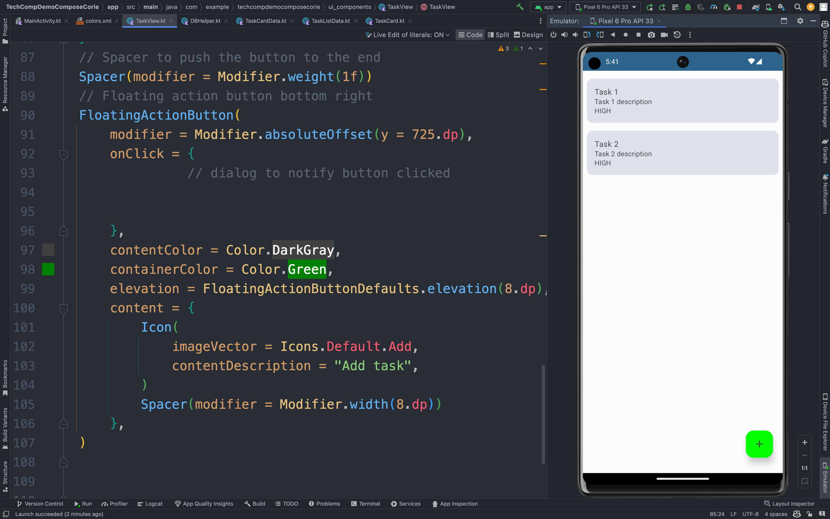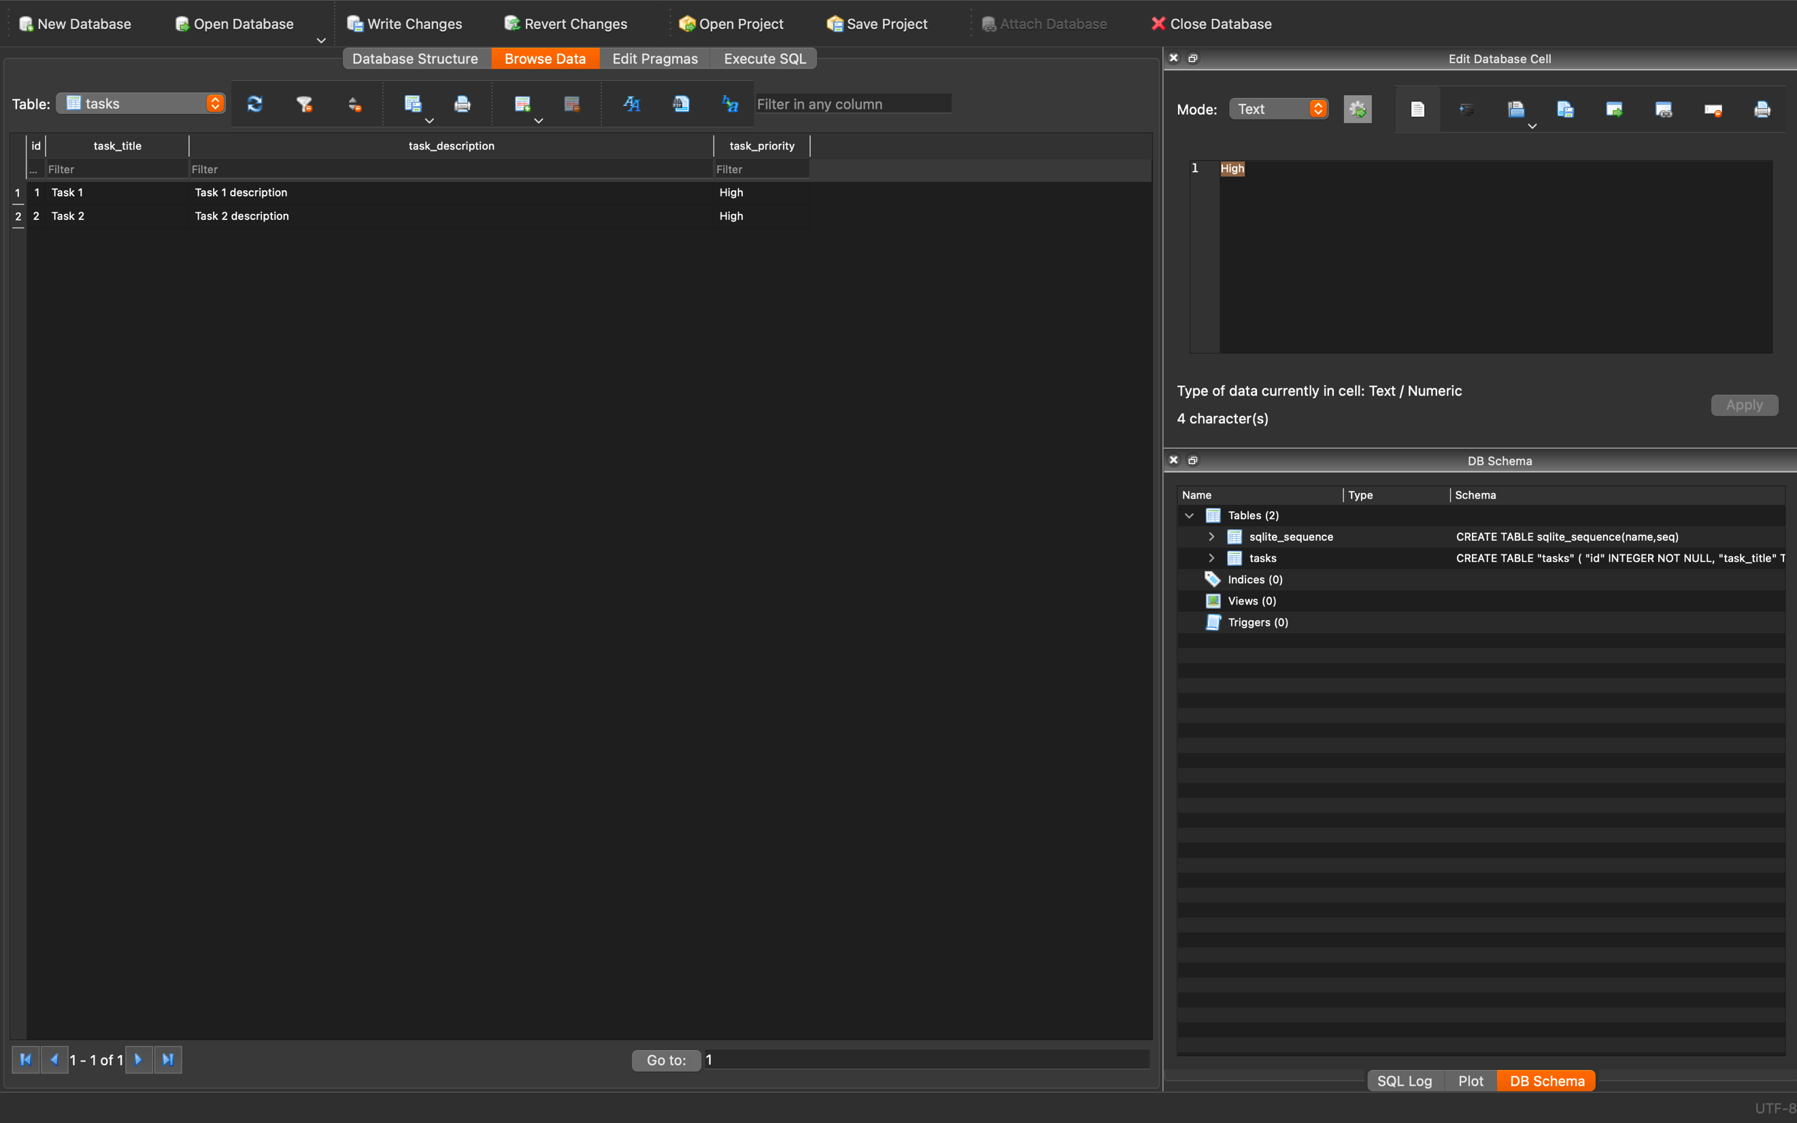

Sam:

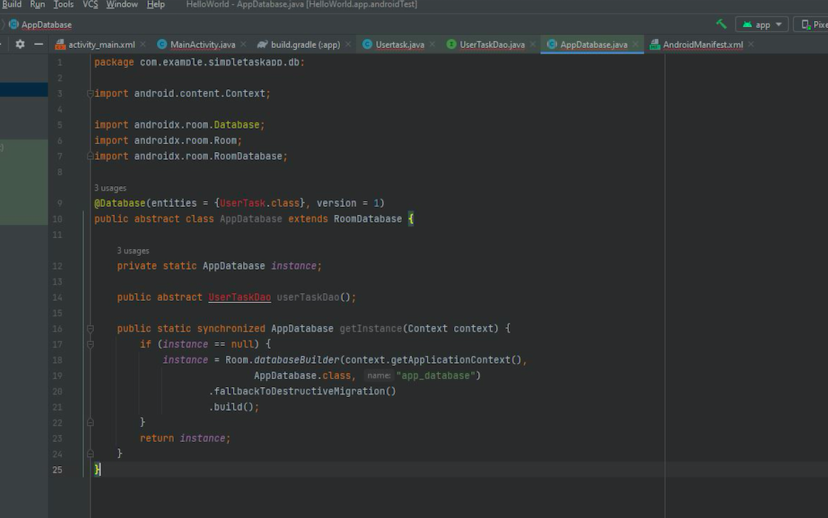

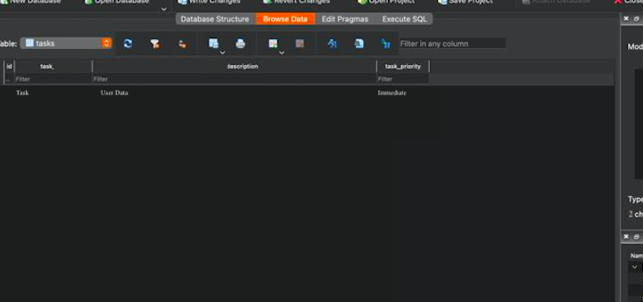

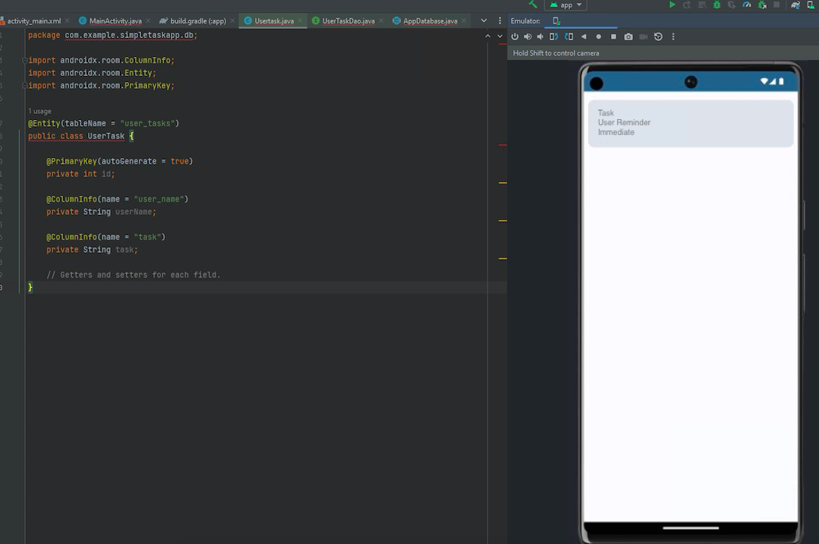

Matt:

Upon Opening the Application, It loads the saved Data onto the View

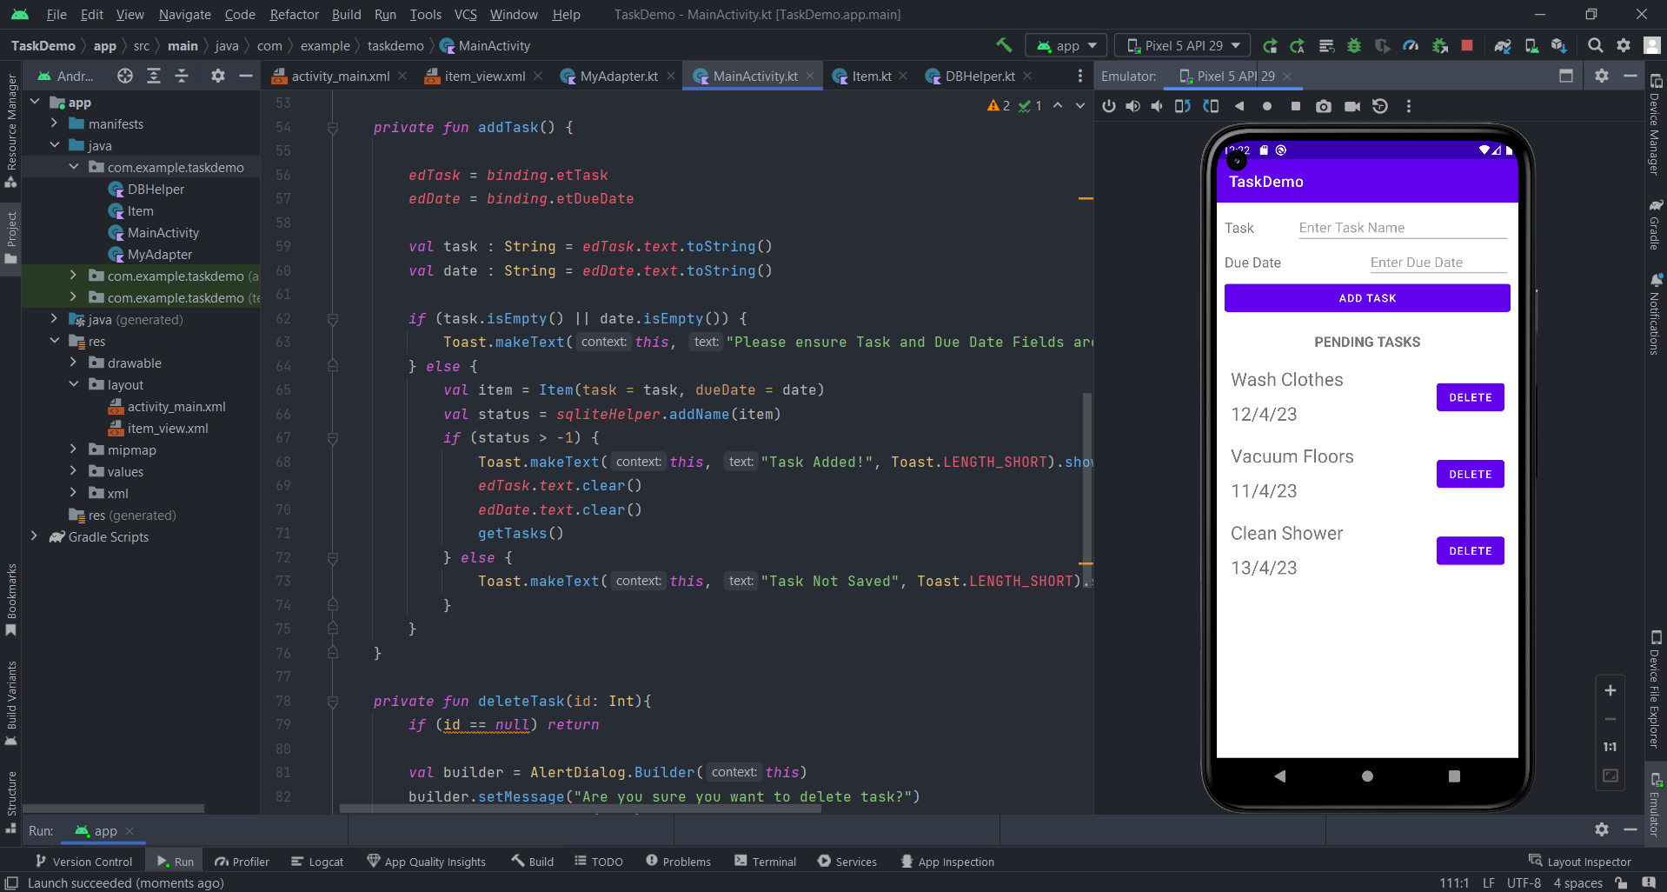

Entering Text into the two text fields and clicking Add Task, adds it to the database and is displayed on the View. As you can see below, Mow Lawn was added.

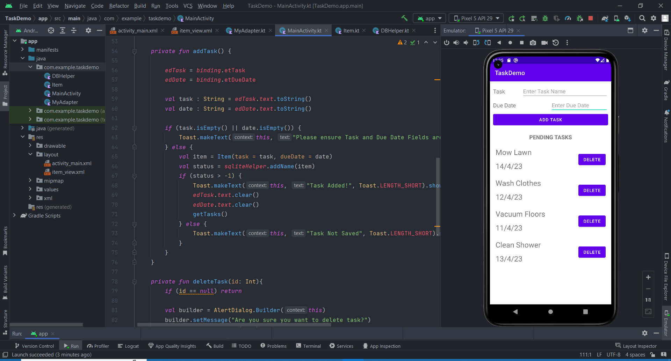

Here is a Database Screenshot:

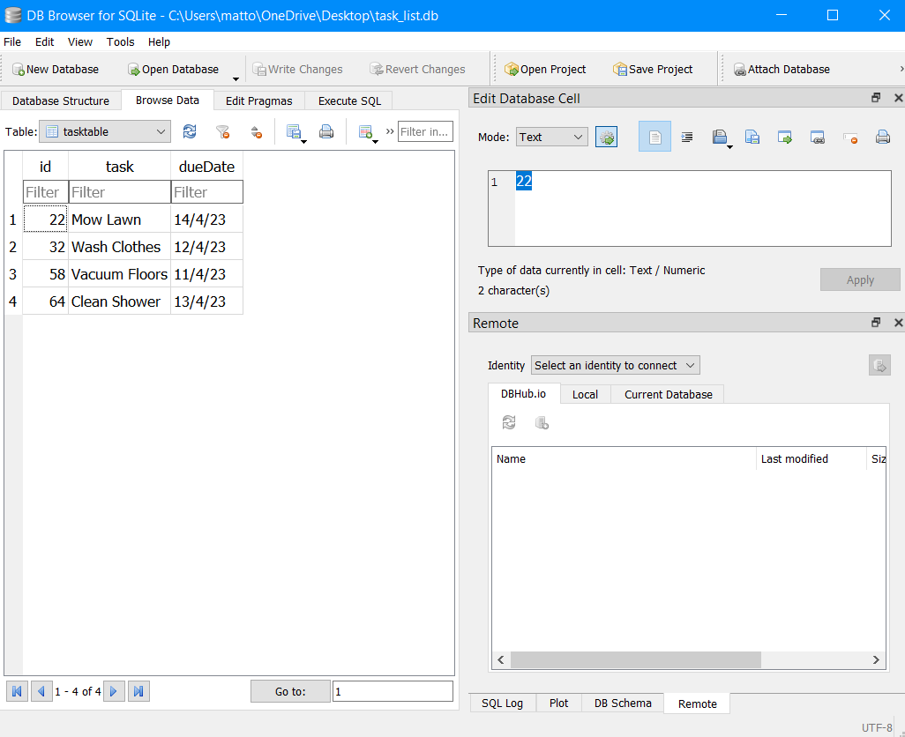

And clicking on the delete button on a task, removes the record from the view and database. In this case, Clean Shower was removed:

